**MIELOS SOLAR POWERED FOUNTAIN MANUAL**

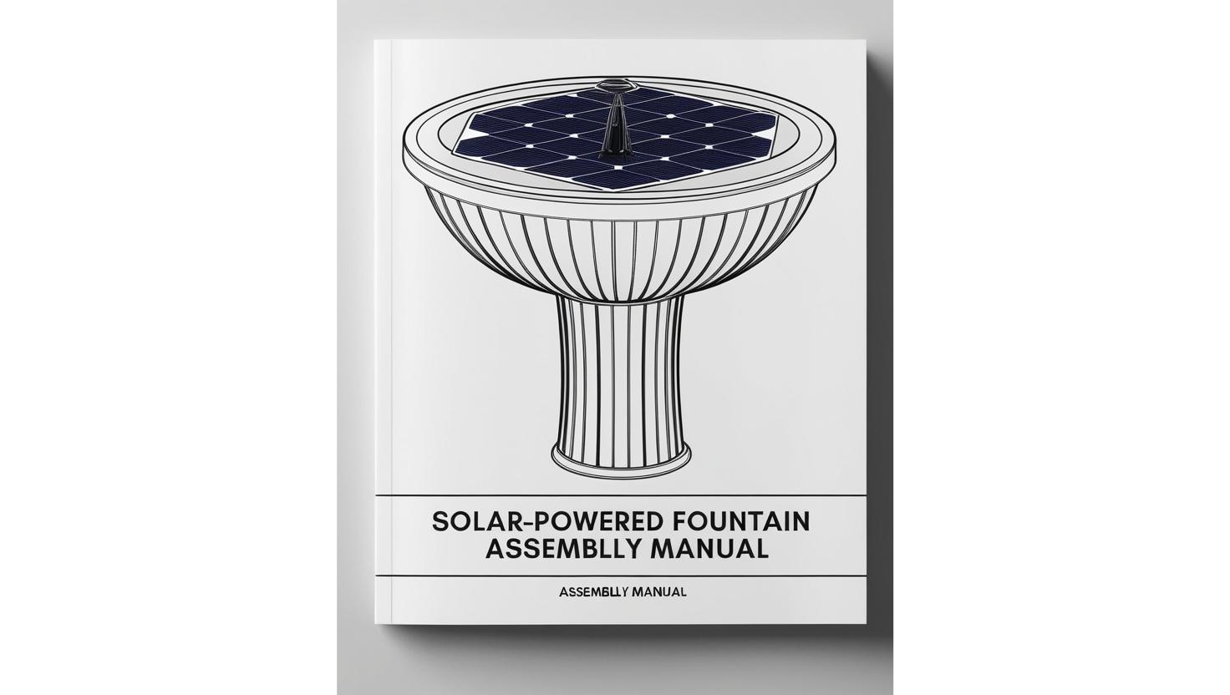

MODEL NUMBER: 1J1-AS01-A021

**Table of Contents. Page**

1. Instructions Overview……………………………………………………………………...2

2. List of Parts……………………………………………………………………………………...2

3. Spray Patterns………………………………………………………………………………….3

4. Assembly Instructions………………………………………………………………………3

5. Product Features……………………………………………………………………………….4

6. Cleaning Instructions…………………………………………………………………………4

7. Contact Us…………………………………………………………………………………………5

**1. INSTRUCTIONS OVERVIEW**

Thank you for choosing Mielos ®. We hope our solar powered fountain brings joy to your garden! Before using this product, please remove the protective film from the equipment.

Below is a list of parts, with instructions on how to assemble them.

**2. LIST OF PARTS**

|  |  |  |
| --- | --- | --- |
| **PARTS** | **NAME** | **QUANTITY** |
| **A** | Solar Panel with Pump | **1** |
| **B1** | Nozzle 1 | **1** |
| **B2** | Nozzle 2 | **1** |
| **B3** | Nozzle 3 | **1** |
| **B4** | Nozzle 4 | **1** |
| **B5** | Nozzle 5 | **1** |
| **B6** | Nozzle 6 | **1** |
| **B7** | Nozzle 7 | **1** |
| **B8** | Nozzle 8 | **1** |
| **C** | Plastic Pipes/Anti-collision poles | **4** |
| **D** | Fasteners | **4** |
| **E** | Filter Cotton | **3** |

**(Figure 1a. List of Pa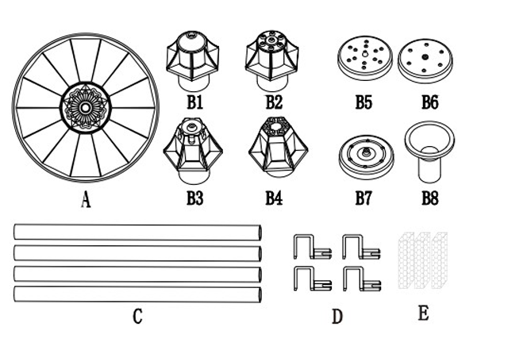rts)**

**3. SPRAY PATTERNS**

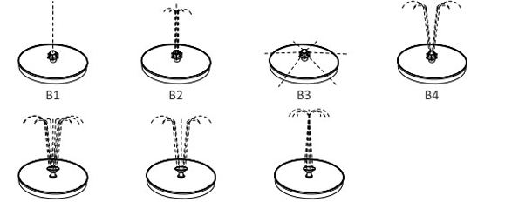

B5 B6 B7

**(Figure 1b. Seven Spray Patterns)**

**4. ASSEMBLY INSTRUCTIONS.**

1. **Choose a nozzle between B1 – B7. Insert it directly into the solar panel (A).**
2. **(Optional) If you want the water fountain to spray at a greater height, you can insert the nozzle you selected, into the connecting pipe (B8) as shown in figure 2.**
3. **(Optional) With the nozzle inserted, place the connecting pipe (B8) in the solar panel (A) as shown in figure 2.**
4. **Before placing the fountain in water, attach 4 plastic pipes (C) onto 4 fasteners (D), and hook them into open slots under the solar panel (A), as shown in Figure 3.**
5. **The plastic pipes help the fountain float, and can be cut according to your requirement.**
6. **After product is assembled, put it in water. Make sure the water pump is completely immersed in water. For best results, keep in a sunlit area.**

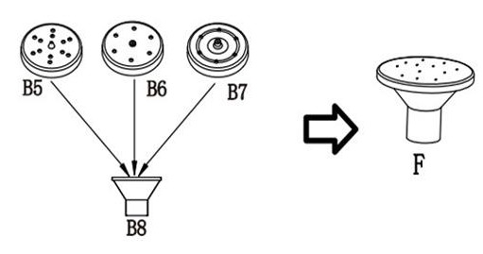 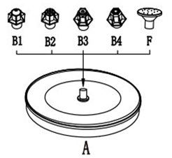

**(Figure 2. Insert nozzle with connecting pipe into the solar panel)**

Attach each fastener (D) to a plastic pipe (C). As shown in fig 3.

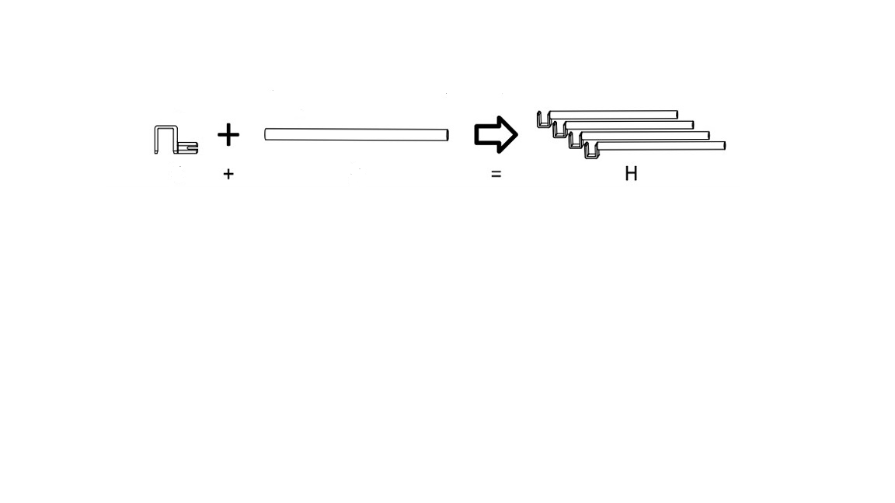

**C**

**D**



**(Figure 3. Attach fasteners to Plastic Pipes)**

Put H into G. As shown in Fig 4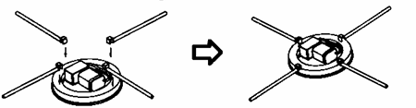

**(Figure 4)**

**5. PRODUCT FEATURES**

* **The water pump works when the sun shines directly on the solar pane. It will stop working on rainy days or at night.**
* **The height of the spray water will depend on the amount of sunlight available.**
* **The lifespan of this product is 10000 hours**
* **There are seven spray patterns.**

**6.** **CLEANING INSTRUCTIONS.**

**If the spray height is too low, please take the filter cotton or rotor out for cleaning and replacement (as shown in Fig.5)**

1. **Remove the nozzle**
2. **Remove the water pump**
3. **Take out the filter cotton or rotor**
4. **Clean the filter cotton or rotor**
5. **Reassemble the fountain.**

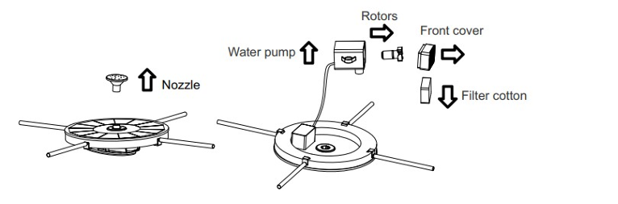

**(Fig. 5. Cleaning the filter cotton or rotor)**

**7. CONTACT US.**

MIELOS SOLAR

2314 Red Rock Road, Aurora, CO, 80013

United States of America.

Tel 18016774212